Ethan Kent

Continue setup lab

**Ubuntu Continued Setup**

The server was updated from 5.15.0-48-generic to 5.15.0-52-generic. October 31st 2022

Continuing with the Ubuntu server first. We’re going to look where our repositories are stored first, what is a repository though? A repository is where you are getting a package from. Think of it as receiving a letter, the sender is giving us a letter and inside the letter is the package we need for the tools we want to use. So, repository is the address of sender who gives us the download we want for tools.

Now let’s look for them in the Ubuntu server so we know where the ones we have by default with the install. To find them we need to navigate to the “apt” directory to get there easily we can use “cd /etc/apt/”

Here is how I jumped from my user directory right to the apt directory. So now that we’re here what’s inside this directory

Inside the directory we can see “source.list” let’s take a look inside. With the screenshot below we can see some comments telling us a bit about the repositories. The repositories themselves are the https addresses, this is where we got the packages we needed when we installed the server.

We can add more repositories by manually typing them into the “source.list” but that could take quite some time to do if we need to add a lot. What I’m going to be doing is use “add-apt-repository” first that needs to be installed to do so run “sudo apt install software-properties-common” then let it install (I installed this on October 28th 2022).

Next let’s install some programs onto the server. Tmux is one that let’s you make multiple windows so you can jump between them and do multiple things. To install it use “sudo apt install tmux” I did this but the program was installed already on the Ubuntu server by default. Here is the path to it.



The other programs I’ll be installing are not on the server, emacs and Fail2Ban. Emacs is a text editor that is large in size so it isn’t installed on many systems by default. Fail2Ban monitors logs and activity on a server to help with security, protecting from things like brute force attacks and DoS or DDoS. So, let’s install them.

As done above we need to use our “sudo apt install” now with emacs at the end. (Installed October 31st 2022) Then it will be installed, let’s use “which” again to see it’s path and where we can find it. 

Fail2Ban will go just about the same except we need to go over the installation since it has some more options for us.  (installed October 31st 2022) let it install and then we have to go into the config to set this up. The directory we need to get to is “/etc/fail2ban/” once in here we can see what’s inside. We want the “fail2ban.conf” but this file consists of the default options, and we want to keep those just in case we ever need to revert to them. So, the “fail2ban.local” file is a copy of the configuration file that I’ll be using to make the changes I want and applied (to copy I used “cp fail2ban.conf fail2ban.local”).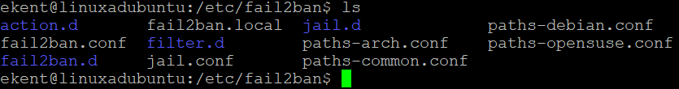

Let’s check the settings in our local file. I won’t be changing any of the settings myself but this is where you would go to make the changes you need for your server.

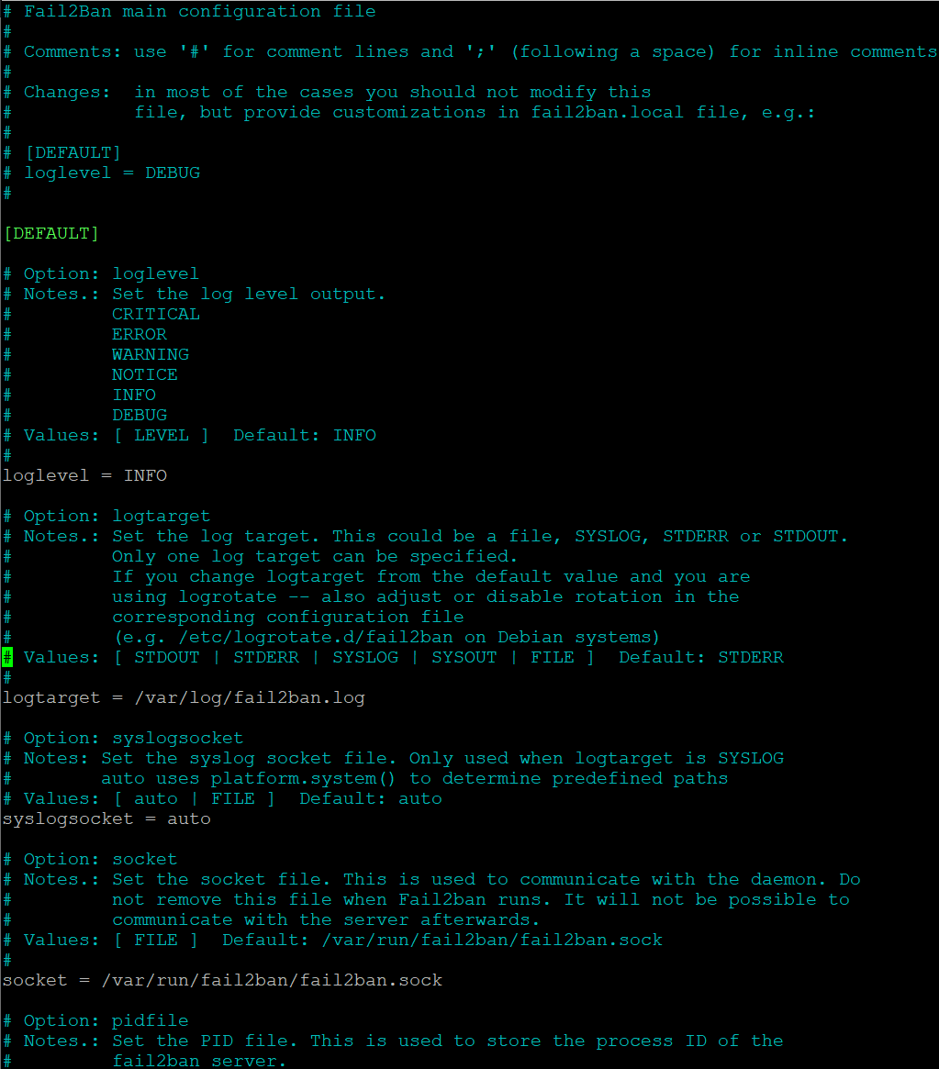

To enable fail2ban we need to enter this command  and now we have to start it and let’s check if it’s running after. There we go, it’s up and running.

Let’s install and run some things you probably won’t find on most servers, cowsay and lolcat.

 (Installed October 31st 2022)

 (Installed October 31st 2022)

Let’s use cowsay for a festive message

We have a happy little cow giving us a happy Halloween!

We can use lolcat to give our boring terminal some color when we want to look at things, let’s look at our old grep lab file but in a more fun way. Look at all those lovely colors!

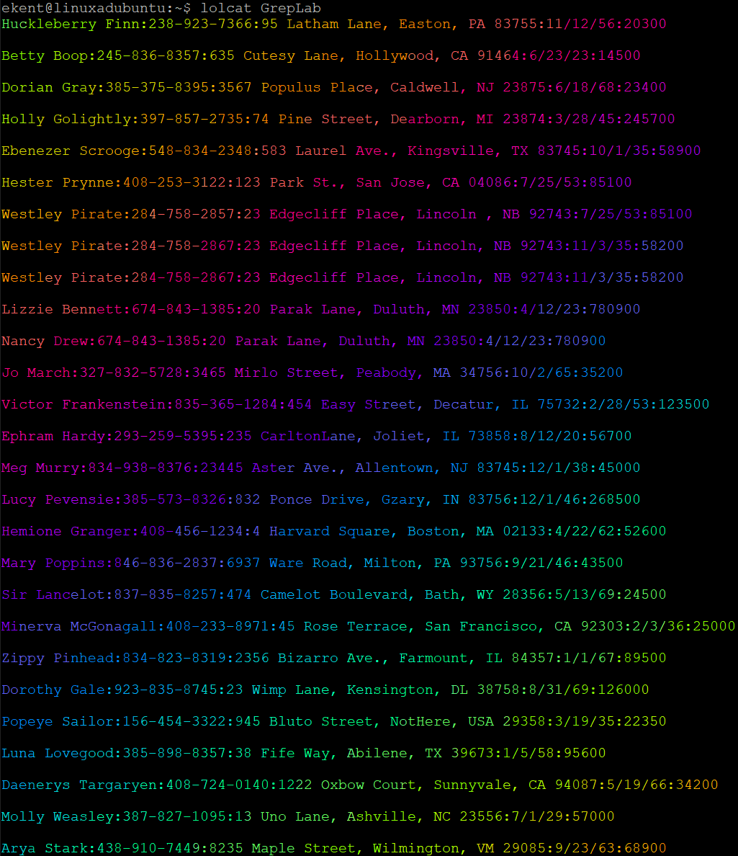

Alright back to work. We need to update something, in this case VI to vim. First, I’m going to take a look at what version of VI I have.



Then I use “sudo apt install” to get the newest version of vi.

 as we can see from the install, I have the most recent version already. This is how you would go about installing and updating though.

**CentOS Continued**

Server updated November 1st 2022.

Now that we’ve finished with our Ubuntu server, we need to do the same on our other server. We’re going to mirror what we went over with the Ubuntu server but there are going to be a few differences with some commands and such. Let’s navigate to our repositories first and see where they lie. To find them in CentOS we have to go to our “/etc/yum.repos.d” if we take a look in here with “ls”

if we cat these two files, we can see the contents are various repos. Now to add a repo in CentOS we need to ether install them using “yum install” followed by the URL for the repo followed by .rpm, the .rpm is the package manager used for Redhat distros. Here is an example from one from one of the sources listed below.

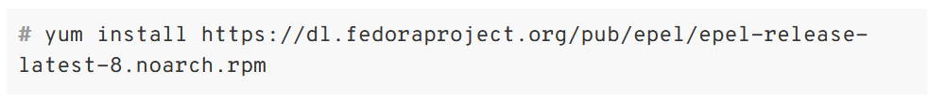 You can manually add them to the centos.repo with a text editor as well inside the centos.repo file.

Now let’s install the same programs we did back in Ubuntu, Tmux, emacs, and fail2ban. In centos we must use yum, so our installation command will look a little different. Here’s how will install the programs.

 (November 1st 2022) (November 1st 2022)

Before we can install fail2ban we need to install epel-release. Here is a helpful guide to help install it on the CentOS system from <https://phoenixnap.com/kb/fail2ban>

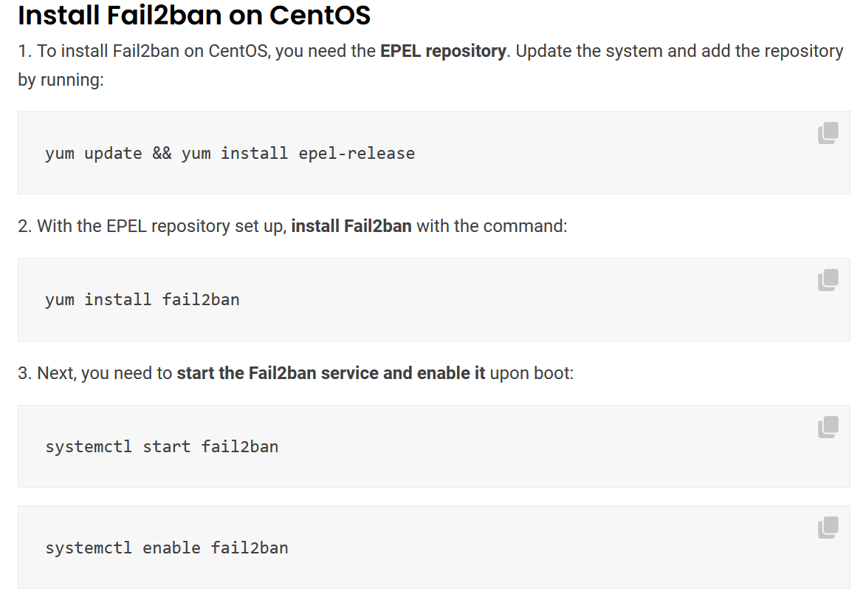

 (Installed on November 1st 2022)

 (Installed on November 1st 2022)

With fail2ban installed let’s go check it again. We can find it in “/etc/fail2ban” make sure to make the “fail2ban.local” file again since we want to have the default configuration available if needed.

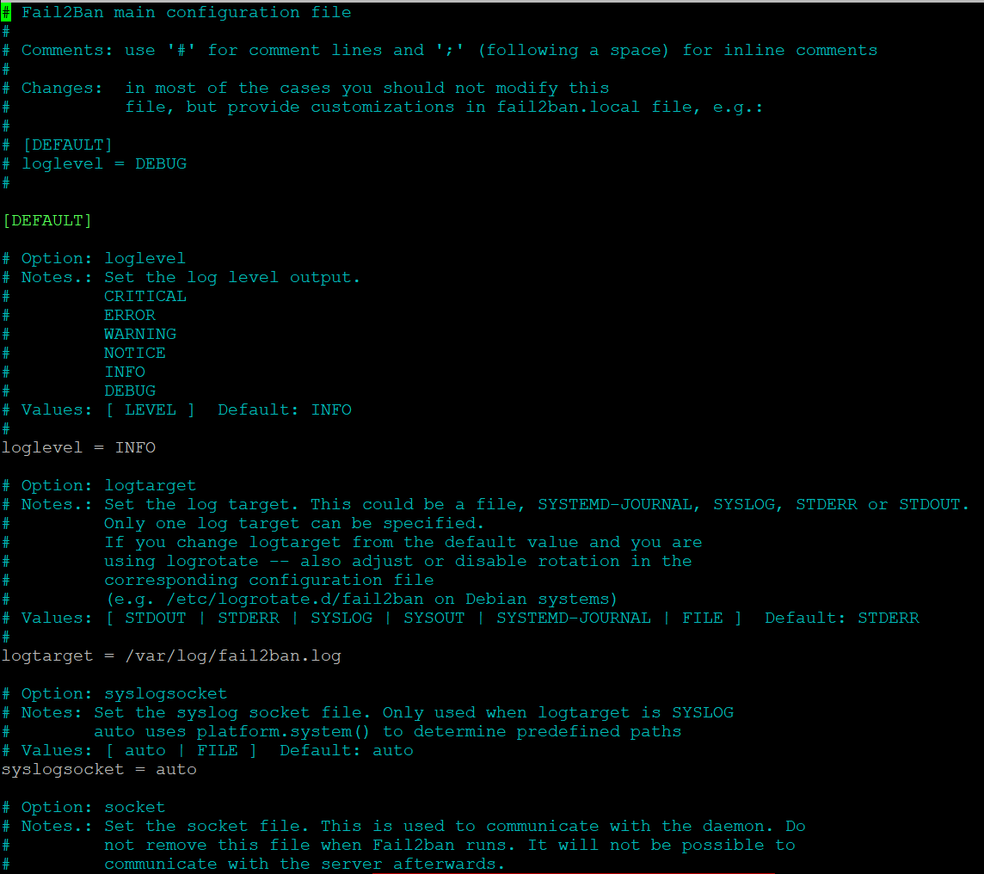

I’m just going to leave it as the default settings like we did for the Ubuntu server. This is the local file as well not the conf. Now to enable it so that it is running on the system.

First is to start the service then we enable it

Now we can go to cowsay and lolcat again. To make this easier in CentOS first install “snapd” This is a repository that we can use to grab certain snaps, a snap being a specific packaging type that cowsay and lolcat use. First we enter in “sudo yum install snapd”  (Installed November 3rd 2022) for me it wasn’t running at the start so let’s check the status with  if it’s down try  and make sure to reboot once you’re done. Now with it working let’s get these two programs, I had to grab the not as fun version of cowsay, ponysay.  (Installed November 3rd 2022) this is how to do an install with snap, we just need to replace yum. Now to run it

I really don’t, on to lolcat.

(Installed November 3rd 2022)

Lolcat used on a file. It looks great!

Next, we can run our update on vi. When I checked it was the latest version so nothing is needed for me but this is how you could do update it if you don’t have the newest version.

Sources used for lab

<https://docs.rackspace.com/support/how-to/checking-linux-repositories-and-logging/>

<https://www.makeuseof.com/how-to-manually-add-linux-software-repositories/>

<https://phoenixnap.com/kb/fail2ban>

<https://www.redhat.com/sysadmin/add-yum-repository>